EXPERINMENT NO 3
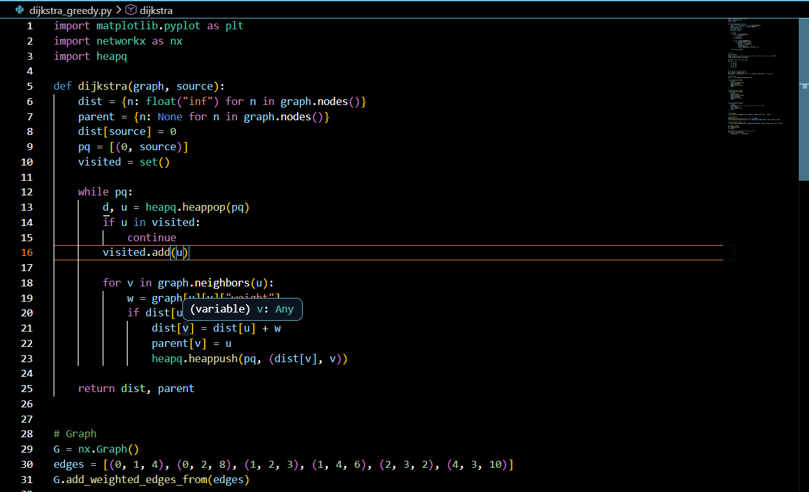
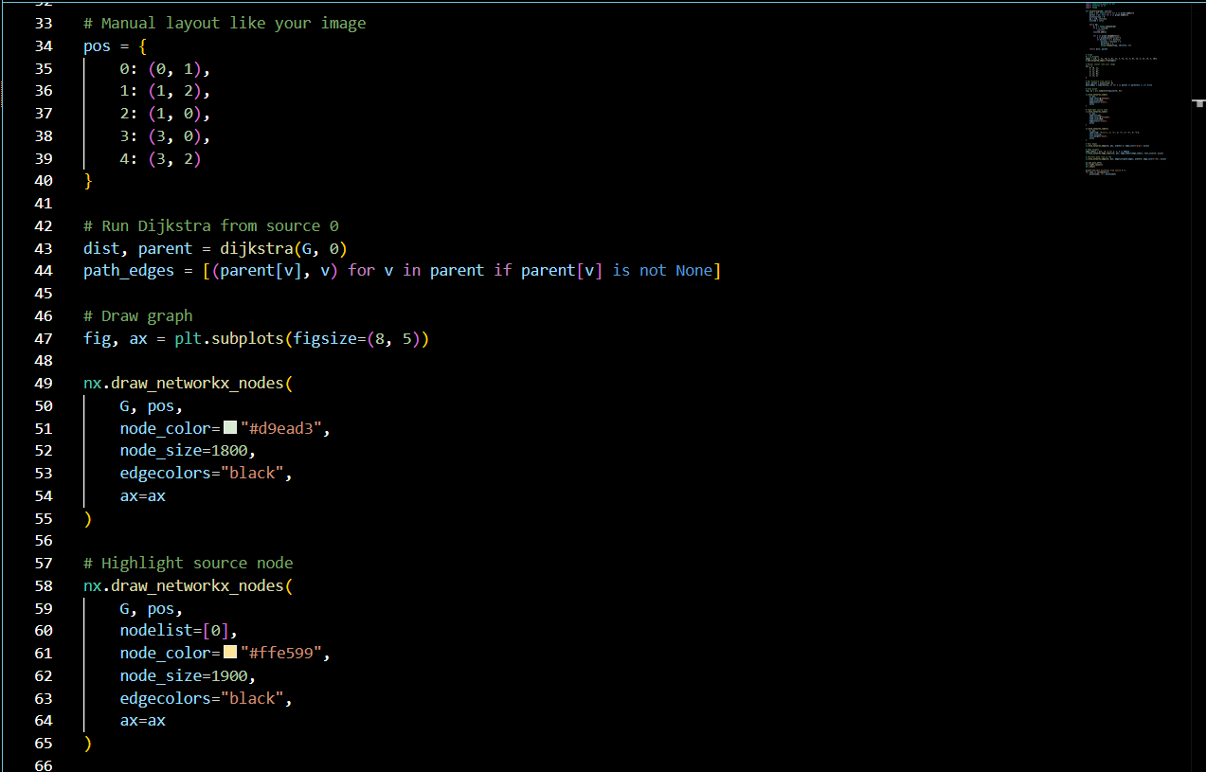
Implement Greedy search algorithm for any of the following application: I. Selection Sort II. Minimum Spanning Tree III. Single-Source Shortest Path Problem IV. Job Scheduling Problem V. Prim's Minimal Spanning Tree Algorithm VI. Kruskal's Minimal Spanning Tree Algorithm VII. Dijkstra's Minimal Spanning Tree Algorithm
